STATE DIAGRAM SPECIFICATION

ONLINE CLOTHING STORE SYSTEM
Online Clothing Store
DGM-06
The Order lifecycle from Pending to Processing, Shipped, Completed, or Canceled.
Version 1.0
September 30, 2026
UEF SHOP

State Diagram Specification
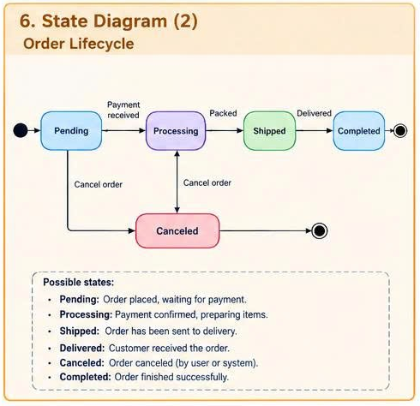
Figure 1. State Diagram for the Online Clothing Store system

Object and Scope
The State Diagram describes the lifecycle of an Order after creation. The five persistent states are Pending, Processing, Shipped, Completed, and Canceled. Delivered is treated as the event that moves an Order from Shipped to Completed, not as a separately stored state in the current version.

State Definitions
State | Meaning | Entry Condition | Allowed Actions
Pending | The order has been created and is awaiting payment confirmation or initial processing. | Create order succeeds. | Confirm payment; cancel the order.
Processing | Payment or COD has been accepted; the store prepares the items. | Payment received. | Pack the order; cancel it if it has not been handed over for delivery.
Shipped | The order has been handed over to the Delivery Service. | Packed and a shipment record is created. | Record successful delivery or a delivery incident.
Completed | The order has been delivered successfully and completed. | Delivered event. | Read only; after-sales handling is outside the standard lifecycle.
Canceled | The order is canceled by the Customer or the system. | A valid Cancel order event occurs. | Read only; restore inventory or issue a refund when required.

State Transition Table
Source State | Event | Guard | Target State | Action
Initial | Order created | The cart and data are valid | Pending | Assign the order number and creation timestamp.
Pending | Payment received | Payment succeeds or COD is valid | Processing | Record Payment and begin preparation.
Pending | Cancel order | Not yet processed | Canceled | Restore inventory and close the order.
Processing | Packed | All products have been prepared | Shipped | Create delivery information.
Processing | Cancel order | Not yet handed over for delivery | Canceled | Restore inventory; refund any collected payment.
Shipped | Delivered | Delivery Service confirms delivery | Completed | Record the completion timestamp.
Canceled | Terminate | No further processing | Final | End the lifecycle.
Completed | Terminate | No further processing | Final | End the lifecycle.

Invalid State Transitions
Request | Required Result
Pending → Shipped | Reject because the order must pass through Processing.
Shipped → Canceled | Reject in the standard flow; handle returns through a separate process.
Completed → Processing | Reject because Completed is a terminal business state.
Canceled -> any active state | Reject; a new Order must be created for another purchase.

